**Java project with Eclipse**

-Project: ATM Bank System.  
(Assignment1)

|  |  |
| --- | --- |
| **Subject name** | Practice on Object-oriented and Interactive Application |
| **Professor** | *Ma difang* |
| **Submission Date** | *2017.11.19* |
| **Department** | *Software Engineering of BJTU* |
| **Student number** | *17309006* |
| **Student name** | *MIN SI WAN (KR)* |

**Table of contents**

1. ***Introduction.*  
   (1) Reference _ ATM Bank System.  
   (2) RUN_ATM Bank System.**
2. ***Administrator.*  
   (1) Connection setting.  
   (2) Login – ID.  
   (3) Account Management.  
   (4) Account registration.**
3. ***Client.*  
   (1) Login.  
   (2) Main**

***Description***

*The* ***Automated Teller Machine*** *ATM Banking System is a banking application developed to perform different banking services through the Automated Teller Machines. The all functions include the regular transactions like cash deposits, cash withdrawals, balance enquiry, balance statements, savings account, and current account; change PIN Number, Credit card Withdrawals and so on. The application design maintains the information of the accounts of various of various customers including the information of the ATM cards, their types Credit cards, Debit Cards and the transactions done by the customers through the ATM machine centers with co-relation of the Banking Services.*

*The stored details also include the information of the various centers in and around the ATM services, which help in the relational maintenance of every transaction in the ATM Machin by the customers with their concerned branch operations.*

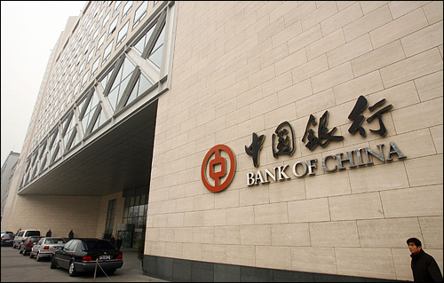

1. ***Introduction – (1) Reference _ATM Bank System.***

This project was created with reference to the following requirements.

Project requirements:   
1. the program is divided into two parts: Client side and Server side  
2. The server side is responsible for managing all bank cards, administrators can increase and delete bank cards.  
 (1) Each bank card is uniquely identified by card number

(2) The new bank card password is "1234", the amount of the card is 0 yuan;

(3) Only the bank card that the administrator has added can login from the client side;

(4) The bank card that the administrator has deleted can’t login from the client side;

3. The client is responsible for ATM common operation.  
(1) After the client enters the correct bank card number and password and the system checks correctly, the client can do other operations;

(2) After login, users can query the balance, withdrawals, deposits, transfer and modify password operation;

(3) When the password is modified, the user needs to enter new passwords two times, which make sure the password is changed correctly

(4) After each client’s operation such as withdrawals and deposit operations, the result of operation should display, such as "successful operation" or "insufficient balance, failure of operation", etc..

4. Imitate the actual interface of ATM as much as possible.

5. For failure operations, the exception capture mechanism is used for error.

6. Server supports multiple clients.

Technology: GUI, Thread, Networking, Exception, Collection, I/O

Submit: java source code, java bytecode, and word document that describes the design and screen copy of your GUI running application

1. ***Introduction – (2) RUN_ATM Bank System.***

All projects are RUN pictures.

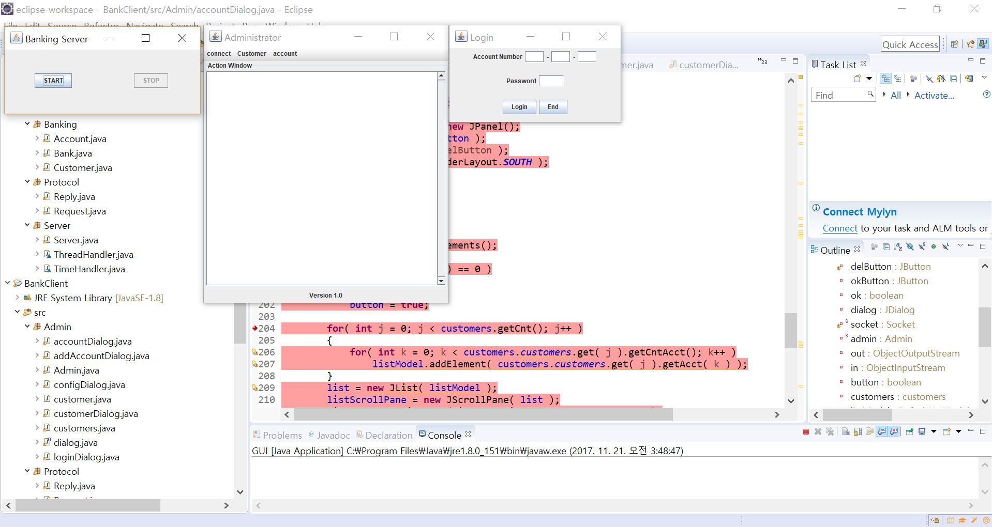  
In above picture, you can see three windows which is “Banking Server”, “Administrator”, “Login”.  
To connect, click “START” button of Banking Server Windows

1. ***Administrator –* (1) Connection setting.**

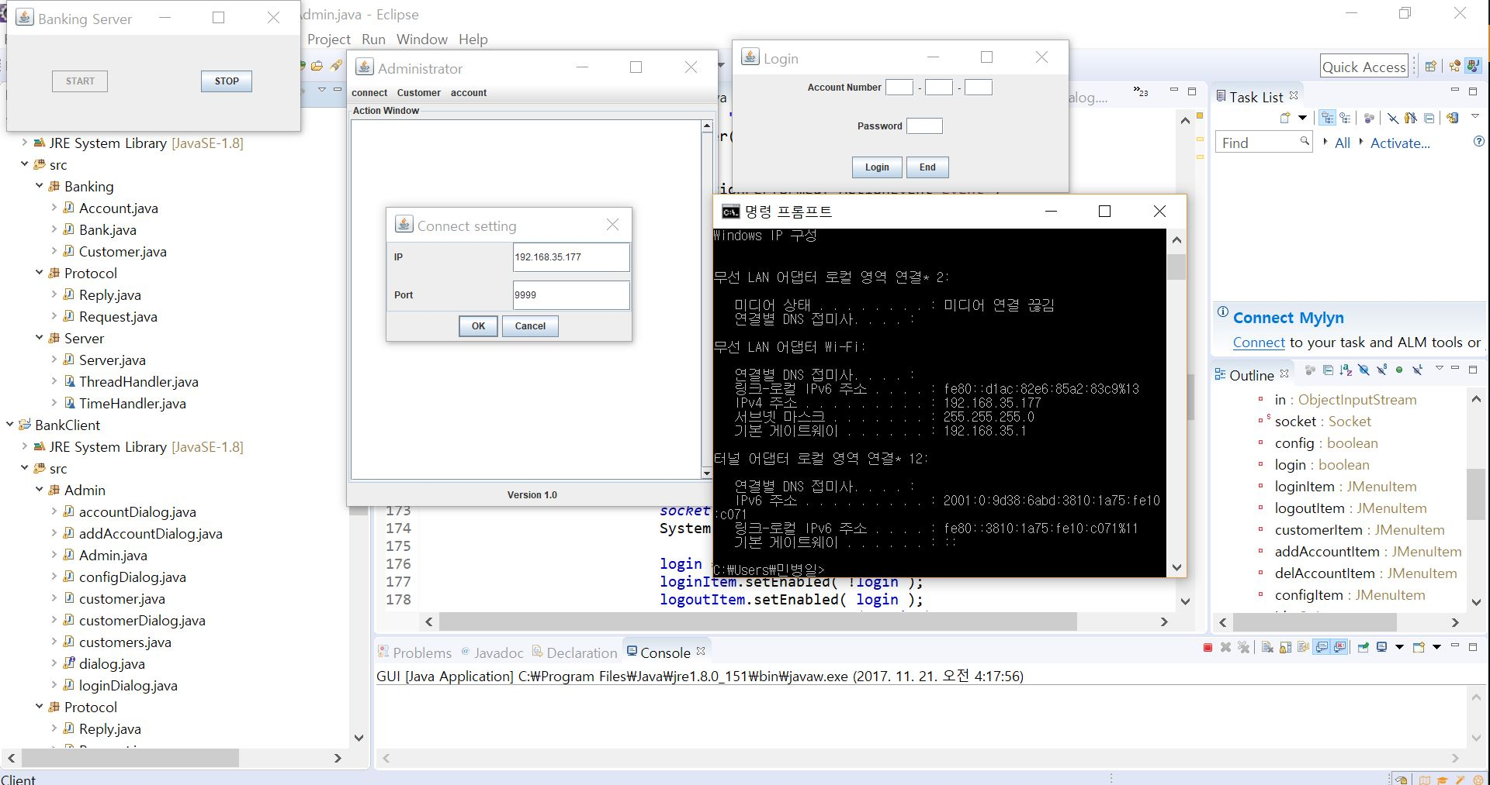  
-Run “cmd” to check my IP.   
-Enter “ipconfig”  
-You will be able to check IP address.  
-connect → Connection setting → Enter IP and port and click “OK” button.  
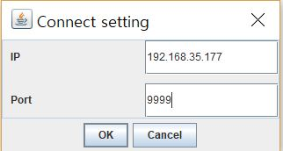

1. ***Administrator –* (2) Login – ID.**

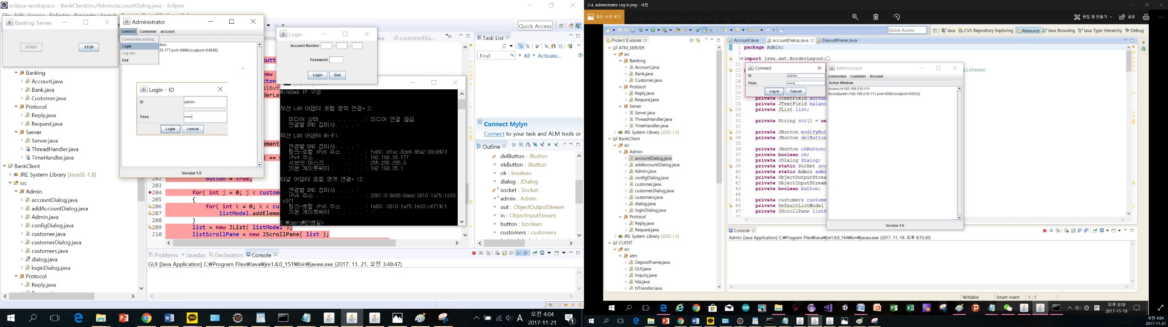

-connect → Login  
-Enter → ID: admin, Pass: 1234  
-Click “Login” button.  
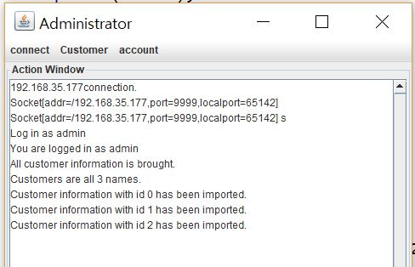  
-You will be able to see that

***2. Administrator –* (3) Account Management.**

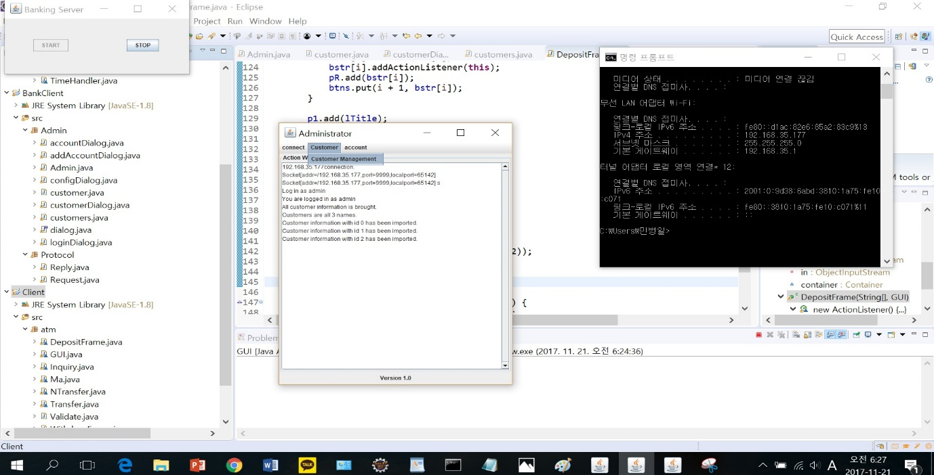  
-Customer → Customer Management.  
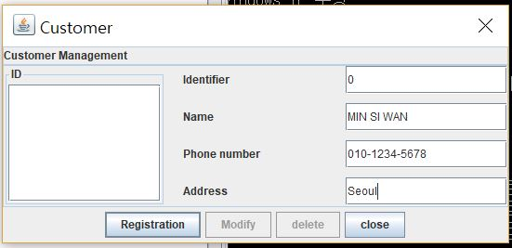  
- Fill in the form  
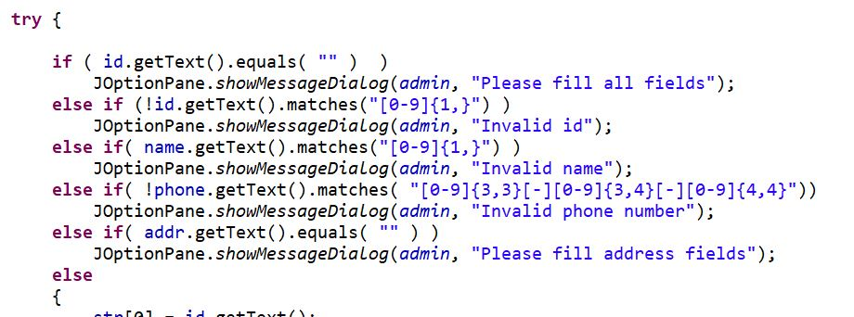

***2. Administrator –* (4) Account registration.**

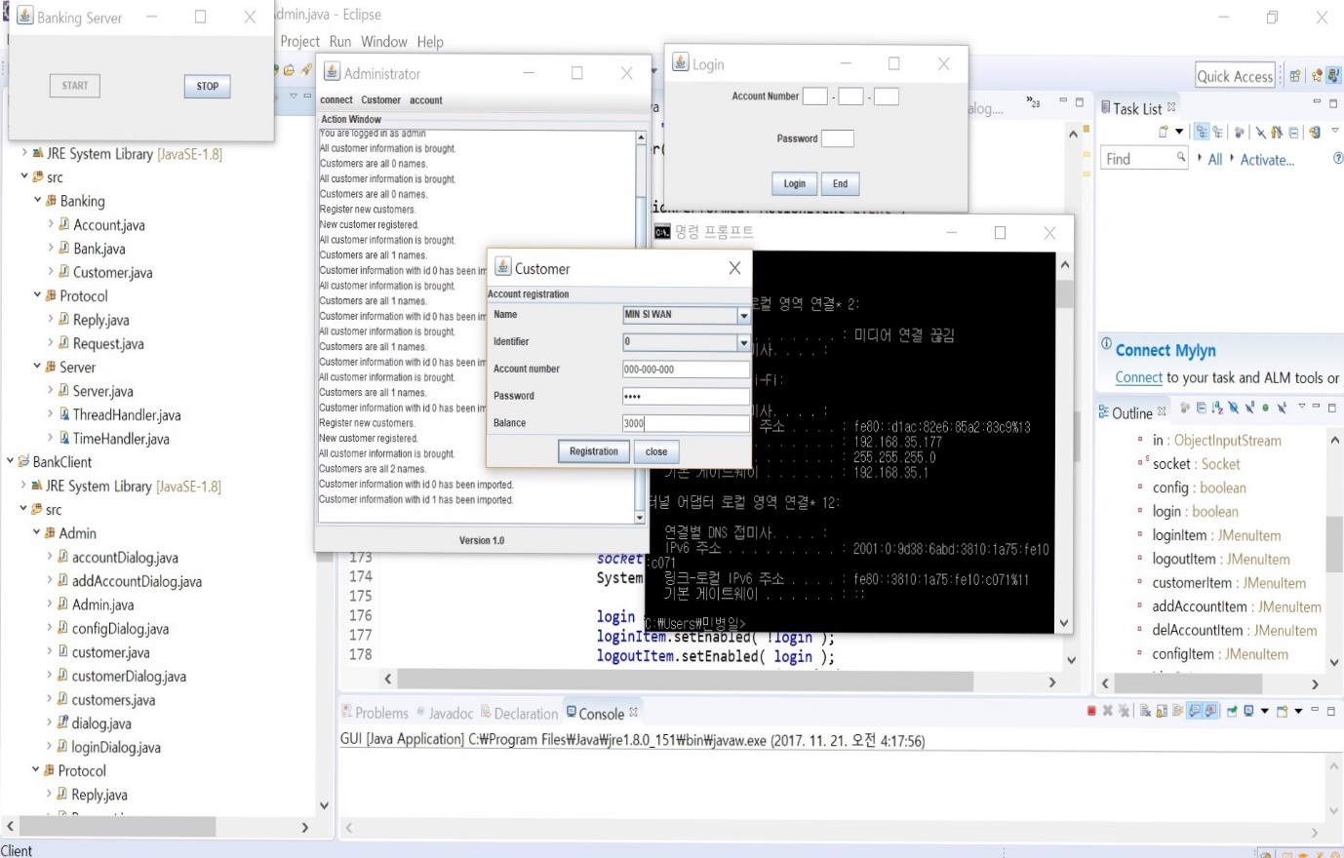  
- Fill in the form  
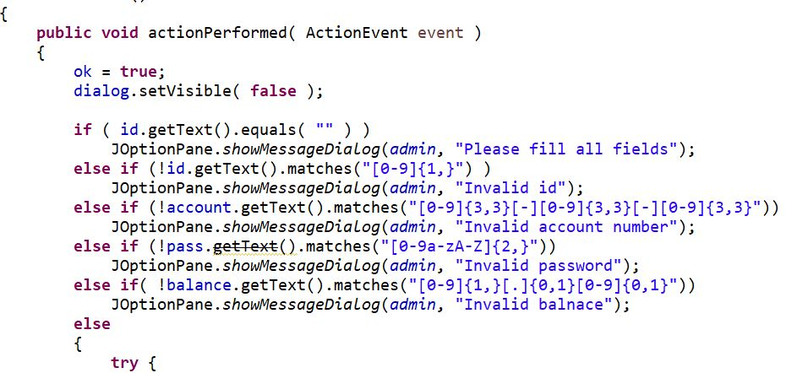

1. ***Client – (1) Login.***

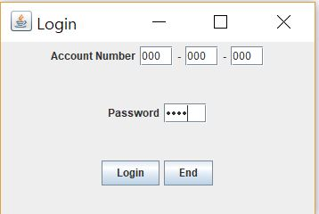

-Enter Account Number and Password you did set. (1234)  
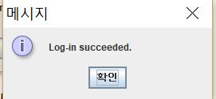  
-You can see this message.

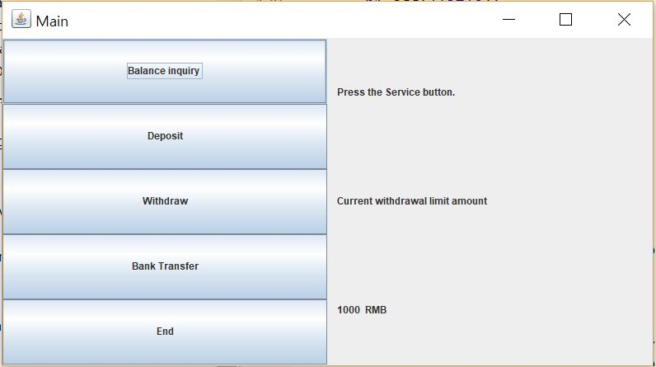

***3. Client – (2) Main***

-If you Click “Balance inquiry” button, you will be able to see bellow window  
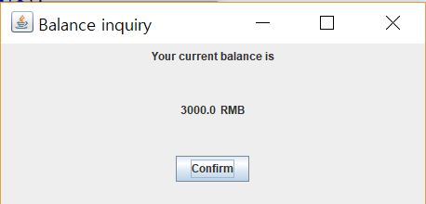

-If you Click “Deposit” button, you will be able to see bellow window  
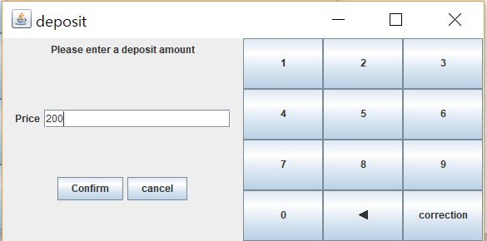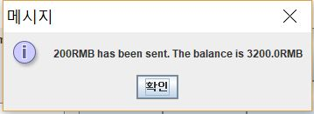

-If you Click “Withdraw” button, you will be able to see bellow window  
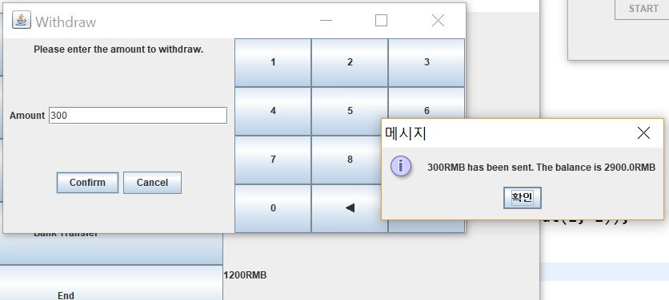

-If you Click “Bank Transfer” button, you will be able to see bellow window  
